Title of the paper in Portuguese / Spanish and English (Helvetica Neue; size 14; bold)
Name of the author 1 - Affiliation, Country. Email (Helvetica Neue, size 9,5; the name of the author in bold)
Name of the author 2 - Affiliation, Country. Email

Resumo/Resumen:
The abstract should summarize the content of the article, presenting the contextualization and general objective, the synthesis of the methodology adopted and the main results. The font of the text should be Helvetica Neue; size 9.5, left alignment and single spacing, and 6pt after paragraph. The text should not exceed 200 words. This template is in the required format and can serve as a guide.
Keywords: 3 to 5 words separated by semicolons (;)

Abstract:
The abstract (in English) is mandatory regardless of whether the body of text is in Portuguese or Spanish.
Keywords:

Chapter (Helvetica Neue, size 12, bold, 18pt before the paragraph and 6 pt after, single spacing)

Subchapter (Helvetica Neue; size 10; bold; italic; 18pt before the paragraph and 6 pt after; single spacing)

This template meets the required standards and can be used as a guide. The document must have a minimum of 6 and a maximum of 10 pages.

The body of text should be properly organized by chapters and subchapters that reflect its content. The font of the text should be Helvetica Neue; size 9.5, left alignment, and spacing of 1.5pt and 6pt after paragraph.

Footnotes and endnotes should not be included.

You should not number the pages.

Citations(Quotes):
The citations must comply with the APA 6th edition.
Direct quotes must be enclosed in quotation marks. When the citation has 40 or more words it must be detached from the text with 2 cm left margin advance, there should be no quotation marks, the spacing should be simple, as the example below..
O Mestrado em Comunicação Acessível do Politécnico de Leiria, criado no ano de 2013, pretende formar especialistas em Comunicação que venham a atuar nas diferentes instituições enquanto mediadores de comunicação, considerando a diversidade de públicos.
O facto de o Mestrado decorrer em regime b-learning tem gerado manifestações de interesse de candidatos de vários países. (Freire & Mangas, 2017, pp.357-358)

Figures
All figures should be centered, numbered, captioned, font and description underneath or alternate text (Picture Format). The caption and font should be positioned below the figure, as shown in the example..
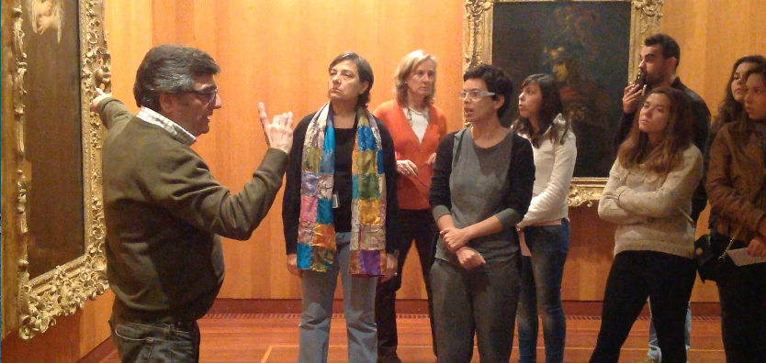
Figure 1. Visit to the Calouste Gulbenkian Museum in the Room of the XVIII Century.
Source: Martins, 2017, p.157
Image description: The photograph presents a moment of the guided visit to the Calouste Gulbenkian Museum in the Room of the XVIII Century. The deaf mediator, Anthony, is left with one hand pointed to a painting on display, and with the other hand communicates in sign language. To the right is the group of visitors who participated in the visit, the oral language interpreter being in the center, observing the painting and the explanation of the mediator.

Tables
All tables must be centered, numbered, captioned, and alternate text (in the table properties select the alt text option and on the Row tab, select the option to put the first line as the header). The caption should be positioned above the table, as shown in the example..

Table. 1. Number os students per school/course
School | Course | Number of students
A | A1 | 25
B | B1 | 15
C | C1 | 32

References

Freire, C. & Mangas, C. (2017). Percursos Formativos para a Inclusão: área da comunicação. In C. Freire, C. Mangas & C. Sousa (Org), Livro de atas da IV Conferência Internacional para a Inclusão 2016 (pp.357-358). Leiria: IPLeiria, ESECS e iACT. ISBN: 978-989-8797-14-8. Consultado em http://iact.ipleiria.pt/publicacoes/2017-2/
Mangas, C., Freire, C & Francisco, M. (2015). Inclusão e Acessibilidade em Ação: Direferentes percursos, um rumo. Leiria: iACT/IPLeiria. Consultado em http://iact.ipleiria.pt/files/ebook/index.html#credits
Martins, P. R. (2017). Museus de Artes e Comunidade Surda: um estudo de caso no Museus Calouste Gulbenkian. In C. Freire, C. Mangas & C. Sousa (Org), Livro de atas da IV Conferência Internacional para a Inclusão 2016 (pp.151-160). Leiria: IPLeiria, ESECS e iACT. ISBN: 978-989-8797-14-8. Consultado em http://iact.ipleiria.pt/publicacoes/2017-2/
Olivencia, J. (2013). De la Integración a la Inclusión: Evolución y Cambio en la Mentalidad del Alumnado Universitario de Educación Especial en un Contexto Universitario Español . Actualidades Investigativas en Educación, 13(3), 1-27.

